

Identifying Native White, Red, and Pitch Pines

By Pamm Cooper, UConn Home & Garden Education Center

There are three native pines that are commonly found in Connecticut. The red pine, white pine and pitch pine are all native to the Northeast part of the United States. To identify these trees, there are key features such as number of needles in each bundle, cone size, shape and color, growth habit and mature bark traits.

**Eastern White Pine Tree (*Pinus strobus*)**

Eastern white pines are a tall, native species and can attain a mature height of 230 feet. Their cones are long, tapering, pendant, curved slightly and up to 6 inches in length. They often are sticky with resin. The needles of the eastern white pine are dark green soft and arranged in bundles of five. They are very pliable, and the edges are serrated.

The bark of young white pines is smooth and light gray in color. As the trees mature, the bark becomes dark gray to black with flat plates separated by shallow fissures.

White pines have a pyramidal or conical growth habit when young and when mature, often have an open layered look due to irregular whorled branch formation. Upper branches curve upward. Many dead branches may be visible during the lifetime of a white pine as branches are easily damaged by heavy snow and strong winds.

**Red Pine Tree (*Pinus resinosa*)**

The red pine is an evergreen conifer characterized by a tall, straight trunk, conical shape, and egg-shaped cones. The red pine gets its name from the red-orange flaky bark that grows on the upper part of the tree. The lower trunk has bark that is rough and scaly, which forms into irregularly diamond-shaped plates with age.

The crown of red pines is dome-shaped and mature trees can reach 50-70 feet in height. It is a self-pruning tree with few dead branches found on it. Branching starts relatively close to the ground.

Red pine needles are in clusters of two and they are sharp-tipped as well as long and brittle, snapping easily when bent. The cones are light brown and oval shaped, 2 inches across and usually occur singly or in pairs. Seeds of red pine are of value to birds and small mammals.

Red pines have a light reddish heartwood while pitch pines have a darker, reddish brown heartwood.

**Pitch Pine (*Pinus rigida*)**

The mature height of pitch pines is 40-60 feet with an open and conical crown that becomes becoming more irregular with age. The heartwood of pitch pine is reddish brown. The pitch pine typically has an irregular or crooked trunk. Small branchlets arise directly from trunk and main branches looking like small sprouts of needles.

Pitch pine needles are in bundles of 3 and are twisted, yellow-green to green, and 2 ½ - 5 inches long. Unlike needles of red pine, they do not snap when bent in half. The bark on older trees is light brown with armor like plates separated by deep fissures.

Cones are ovoid, 2 to 4 inches long, light brown to gray in color, with scales tipped with a short, sharp, stout prickle. This trait of the prickly scales is a key to distinguishing cones of red pine from those of pitch pine especially if needle clusters cannot be looked at to determine if needles occur in bundles of 2’s or 3’s. Cones of pitch pine also occur in clusters of 3-5, which are often whorled around a stem or branch.

Pitch and red pines occur in sandy soils with a low pH. White pines prefer a moister, slightly acidic soil. All three pines do best in well-drained soils and in full sun, although all can be found in forests. When you come across a pine in the wild, in a park or other landscape setting, see if you can identify it by comparing the features discussed above.

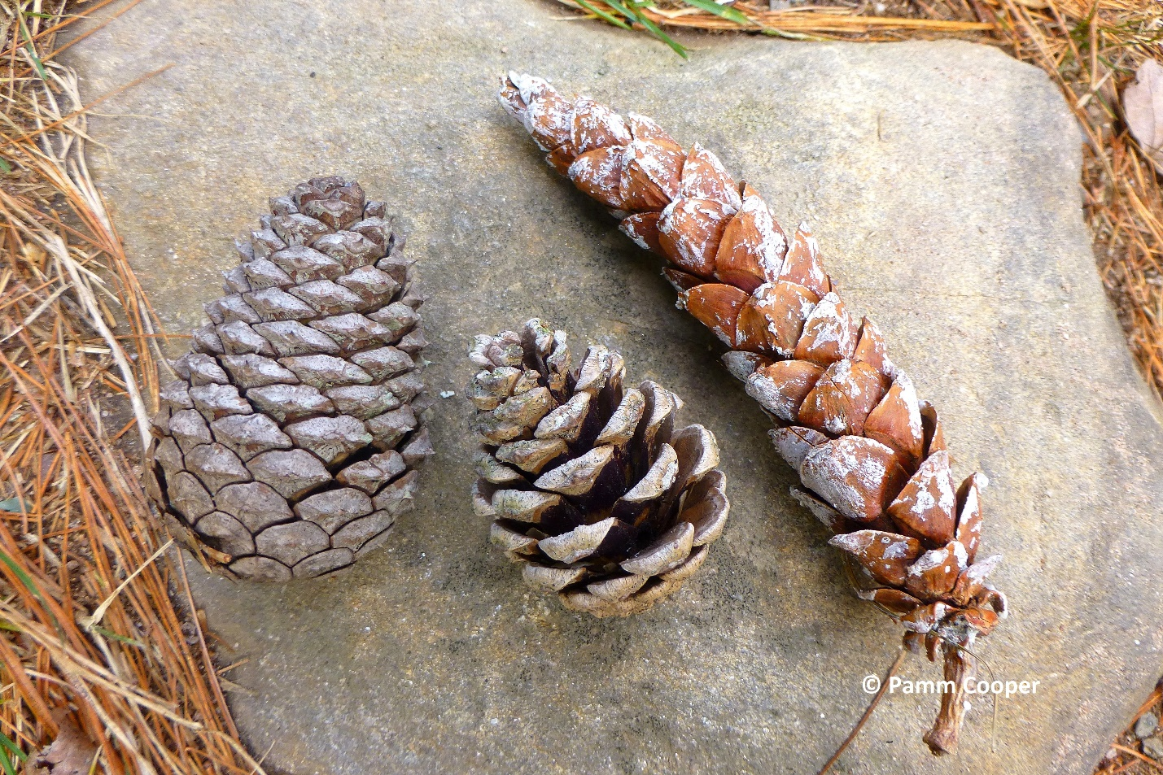

Left to right, pitch, red and white pinecones.

For information on growing native pines or queries on other gardening topics, feel free to contact us, toll-free, at the UConn Home & Garden Education Center at (877) 486-6271, visit our website at [www.ladybug.uconn.edu](http://www.ladybug.uconn.edu) or contact your local Cooperative Extension center.